**Lab 1 Solution/Guide**

**CST: 2234**

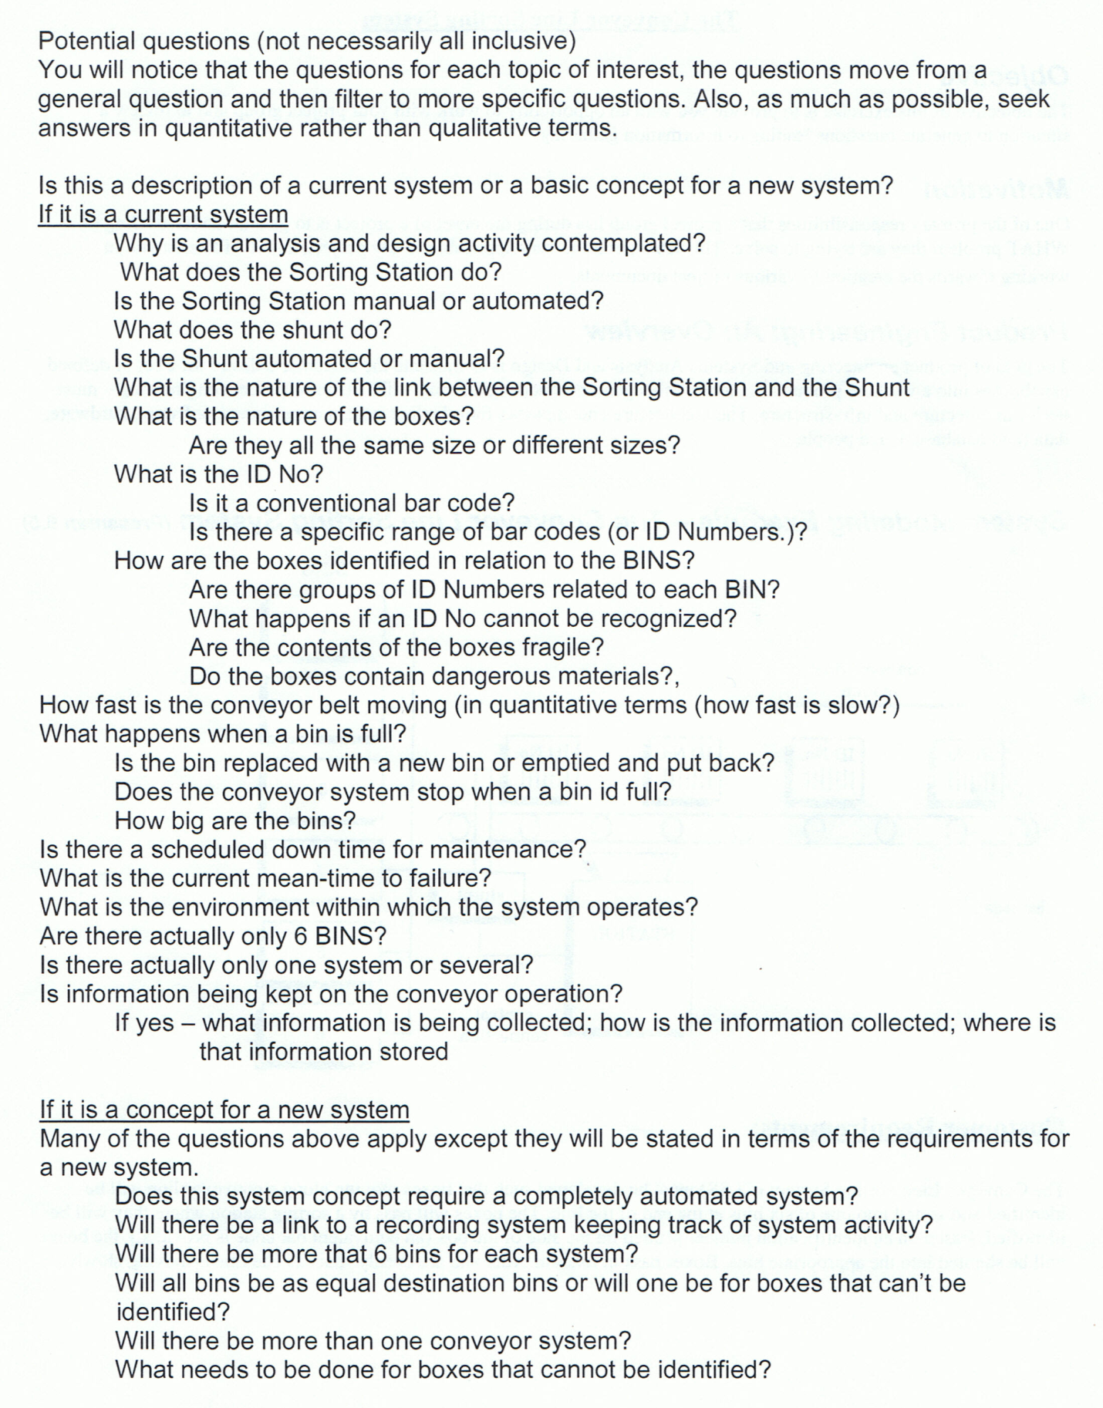

**If System Exists:**

* How shunting works?
* How much automation is present?
* Link between sorting station and shunting?
* Nature, type, size and weight of boxes?
* Fragile vs Non fragile items in the boxes
* Dangerous items in the box?
* Bar code types, and range?
* Bin ID, size and capacity?
* Bin ID, box ID if not available?
* Belt speed, size and capacity to hold weight?
* Run time failure probability
* Environment
* Database used; type/kind, size, software and hardware

**System Does not exist:**

* Need fully or partially automated system?
* record/ backup/ database/software/ hardware?
* Information regarding conveyor Belt system i.e. belt size, capacity, strength, operation, failure and success rate?
* Numbers of bins and sizes?
* Number of belts/system keeping in view the size of business ?
* All those parameters which have been discussed above...